DEEPSEEK – R1
Ollama(deepseek-r1) + Langchain + Streamlit
- Min system Requirment : 8gb Ram
- Login to https://ollama.com/ Download & install Ollama
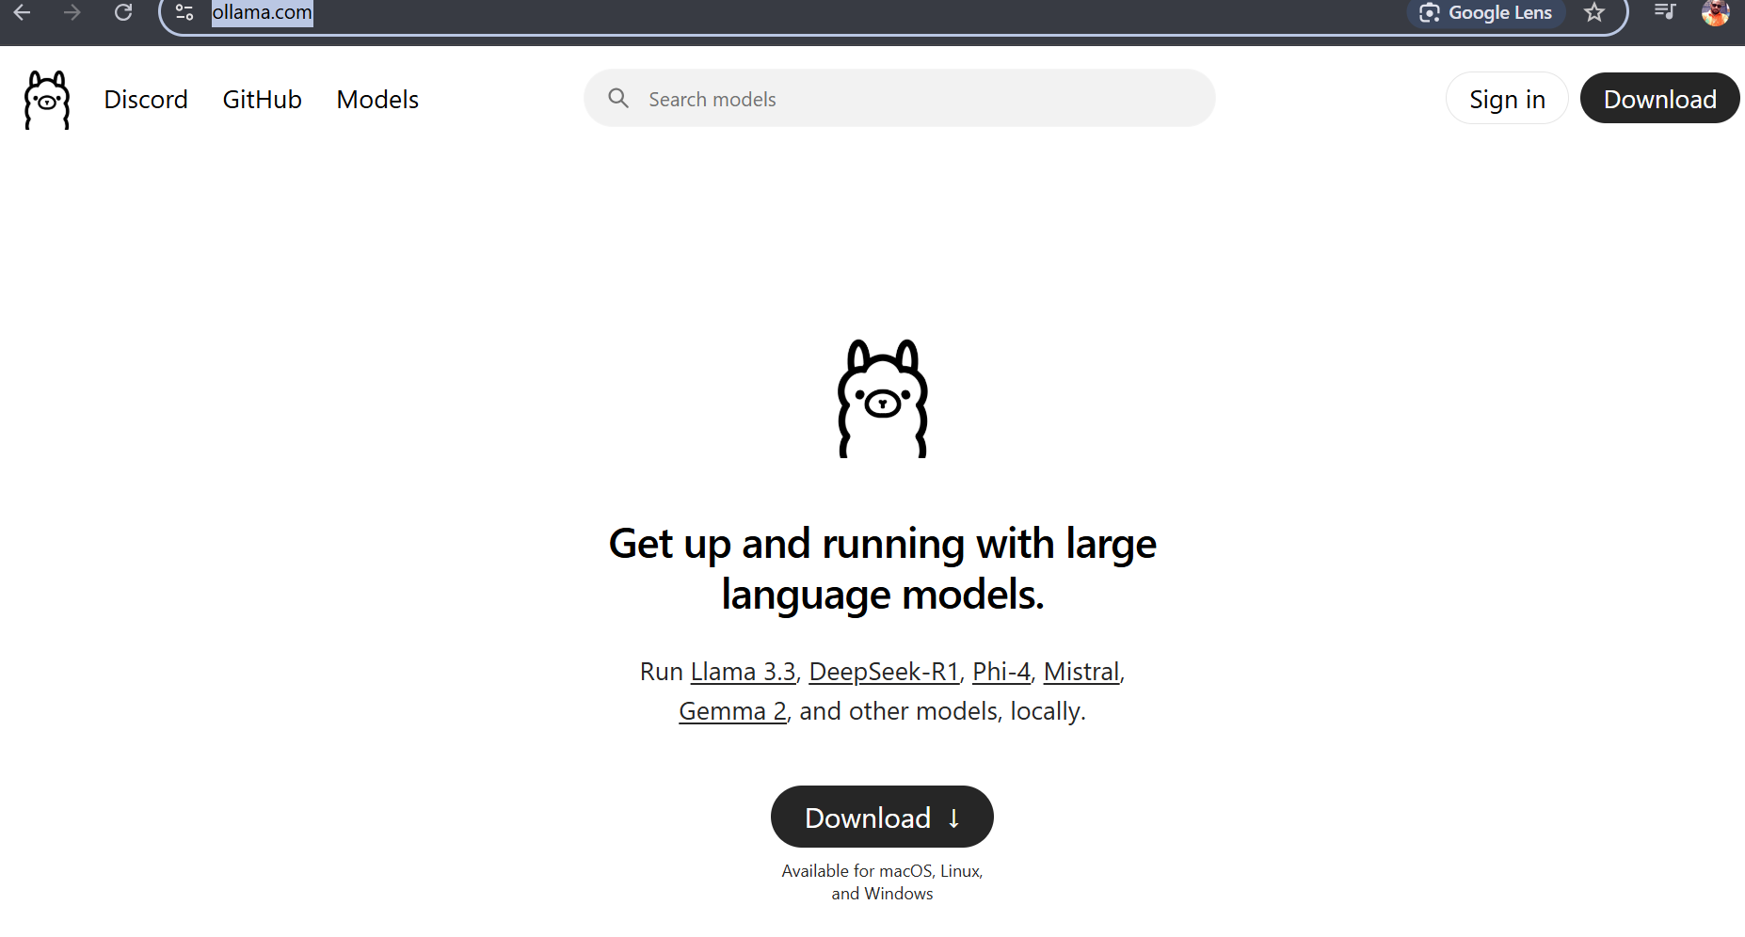
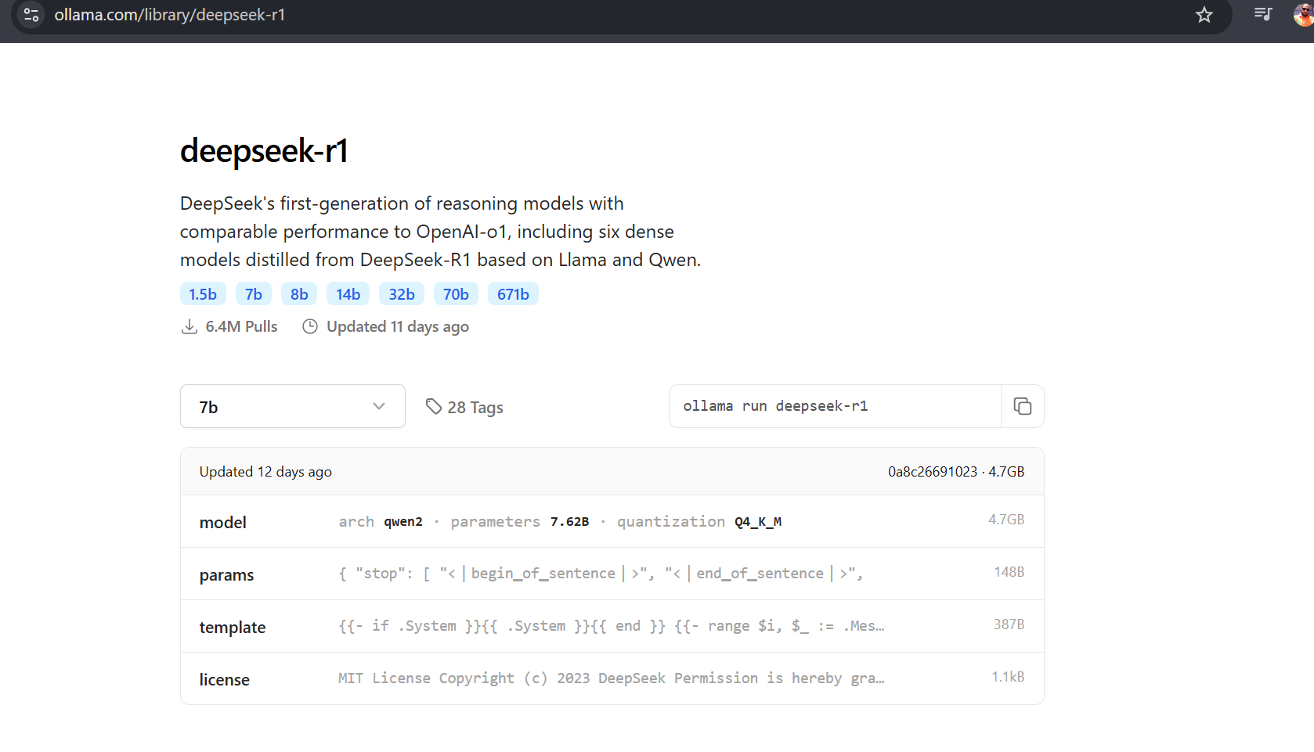
- DeepSeek-R1 model locally. The system requirements vary significantly based on model size.
- 1.5B model: Works fine on 8GB RAM and 4GB+ VRAM (even integrated GPUs can handle it with CPU offloading).
- 7B - 8B models: Need 16GB+ RAM and 12GB+ VRAM (RTX 3060 or better) for smooth performance.
- 14B+ models: Require at least 24GB VRAM (RTX 3090/4090) and 32GB+ RAM for decent speed.
- 32B - 70B models: Need A100 80GB+ or multiple GPUs, plus 64GB+ RAM (offloading works but is slow).
- 671B model : Impossible to run locally—it requires huge cloud compute resources.
- System Cmd Ollama
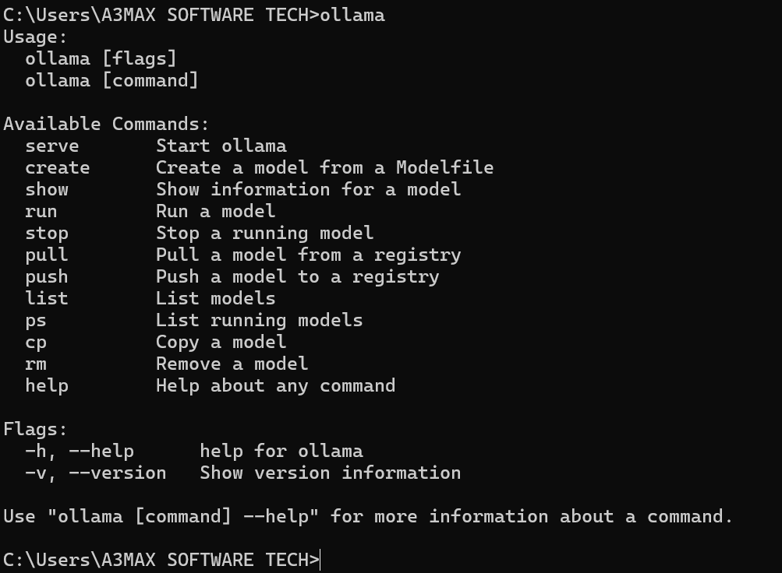\
- Vscode terminal Ollama run deepseek-r1 first it will download 4.7GB & then it will give a prompt to use user int
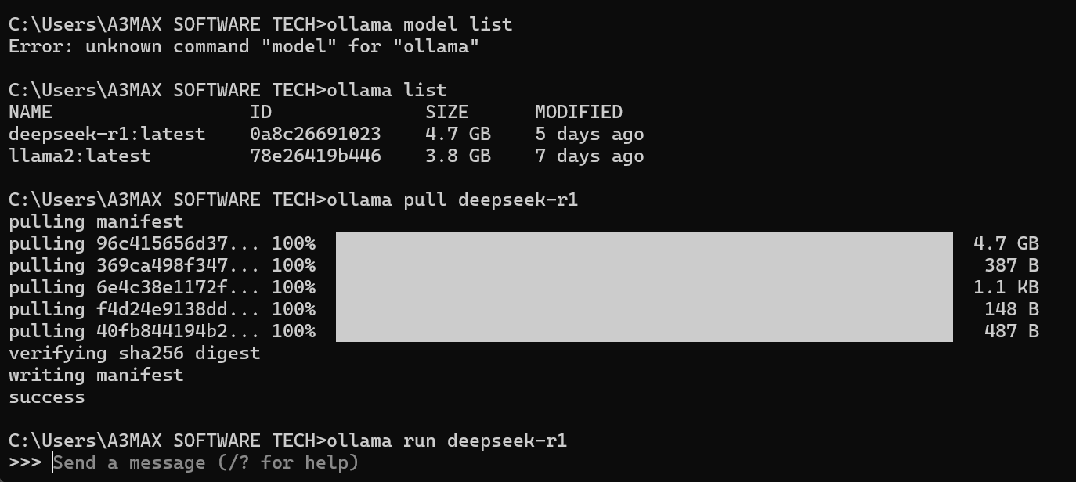
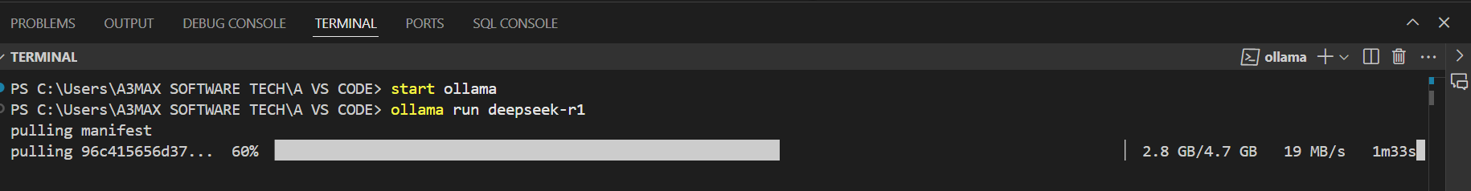
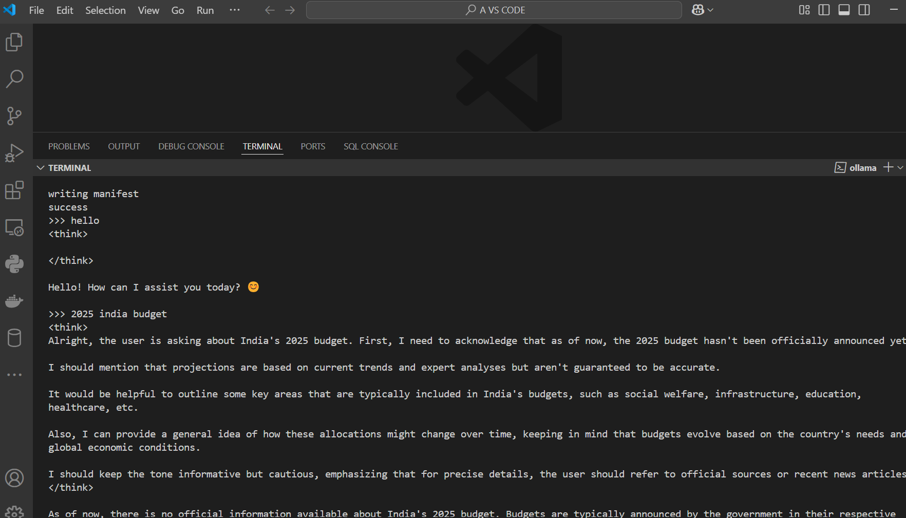

- Let’s integrate OLLAMA- DEEPSEEK along with LANGCHAIN FRAMEWORK

- VS Code Create new folder Ollama Install below library
####Install packages
pip install --upgrade langchain langchain-community

#### Provides access to the ollama models.
pip install -U langchain-ollama

#### Install streamlit.
pip install streamlit

- Create new python file & start write the code

